**GENERAL INFORMATION**

Intelligence Support to Operations

1st September–19th September 2025

*University of Defence*

*Brno, the Czech Republic*

**How to apply for the course?**

* Please use the attached Application Form (if you do not know your arrival and departure data at this stage you can forward it later on) and send it to the University of Defence POC OF-4 Radovan Vašíček [radovan.vasicek@unob.cz](mailto:radovan.vasicek@unob.cz);
* The latest date for registration is Monday, 31 March 2025;
* Participation will be assigned on a first come, first served basis;
* The number of international participants shall be limited to 10 PAX for RECCE sub-module and 10 PAX for INT sub-module;

**Accommodation and meals**

* Accommodation, teaching aids and meals during the training activity will be free of charge in all locations. Please note that due to the dining facility restrictions, free meal will be provided from 1 September (starting with breakfast) to 5 September (ending with dinner) and 8 September (starting with breakfast) to 19 September (ending with dinner).
* The sending organization must cover transportation costs to Brno and daily allowance.
* Accommodation will be organized at the University of Defence dormitory. During the live training event in Libava Military Training Area (MTA) the participants will be accommodated in military log cabins (see Annex A of this document for relevant maps).
* All outdoor activities will be monitored by professional medics. Nevertheless, the participants are strongly encouraged to arrange for their own student travel and health insurance.
* The University of Defence assumes responsibility for providing necessary assistance and guidance from the moment of arrival until departure to/from Brno. International students are required to report any concerns or issues to their designated course leaders. The course leaders will serve as the primary point of contact and will coordinate with the relevant authorities in the students' home countries to address any matters effectively.

**How to get to Brno, the Czech Republic?**

* Arrival on Sunday, 31 August 2025; departure on Saturday, 20 September 2025, or Sunday,   
  21 September 2025.
* There are two airports you can use to reach Brno:
* Prague Václav Havel airport (the Czech Republic) – connections to major European airports.
* Vienna airport (Austria) – connections to major European airports.
* There are frequent bus and train connections between Brno and the aforementioned airports.
* The participants are expected to arrive at the University of Defence where they will be met by the representative of the university and receive further guidance and assistance.
* **The check-in and meeting point is at the University of Defence dormitory, Tučkova 23, 662 10 Brno.**

**Weather forecast**

* Daytime temperatures in the Czech Republic in early September will probably be about 20°C, but nights can get colder, down to 5° C. Please pack and dress accordingly!

**Leisure time**

* The participants can enjoy their free time off during Week 1 (1–5 September 2025) after the academics and during the whole weekend of 6–7 September 2025. As the venue will conclude on 19 September 2025, the participants can also exploit leisure time before their departure on 20 or 21 September 2025.
* Two organized social venues are planned for Week 1:
* a guided tour to Brno city centre, including sightseeing and hosted dinner;
* an excursion following Napoleon's footsteps at the victorious Battle of Austerlitz, also called Battle of Three Emperors.
* Please, don’t forget to pack some casual clothing as well.
* Rest assured that card payments are accepted in most shops/restaurants/bars in the Czech Republic.

**Covid-19 information**

* There are no restrictions or requirements set for the course participants.
* In the unlikely event that the epidemiological situation in the Czech Republic changes and new regulations or restrictions are issued on national level, the University of Defence will inform academies sending cadets to the Czech Republic as a first thing.

**Tentative programme of the course**

* The overall classification of the course will be “UNCLASSIFIED EXERCISE”.
* The course will be divided into two main parts – academics (Week 1) and field training (Weeks 2–3).
* The participants will be divided into two sections (INTEL or RECCE) according to their specialization.

Week 1

* The academics will be conducted at the University of Defence facilities in Brno, daily from 08.00–16.00. Additional hours of self-studied might be required for reflecting the academics. An on-line training session is included within the first week.

Week 2

* The battle staff and field training will commence on Monday, 8 September 2025, when the participants will be transported to Libava MTA.
* Week 2 will be dedicated to the battle staff training, running daily from 07.00–20.00.

Week 2/3

* After completion of the battle staff training, the reconnaissance teams will be deployed into their named areas of interests, where they will execute their tasks on 24/7 basis until 18 September 2025.
* The members of intelligence staff will be divided into several intelligence sections, working 12-hour shifts (day/night).

|  |  |  |  |
| --- | --- | --- | --- |
| **Date** | **Title** | **Location** | **Topic** |
| 1–5 SEP 2025 | Academics  (Week 1) | Brno | Common Activities (INT + RECCE teams)   * Operating Environment * Introduction to the Event Scenario   Intel Sub-Module (INT teams)   * Intelligence Support to Operations * Intelligence Cycle * ISR Process * Intelligence Procedures   Recce Sub-Module (RECCE teams)   * TLP Planning Process * Observation * Patrolling * Medical Training * Dismounted Tactical Movement * Signals Training |
| 8–12 SEP 2025 | Battle Staff Training (Week 2) | Libava MTA | * Live Training Setting and Preparation, Mission Planning |
| 13–14 SEP 2025 | Mini Exercise  (Week 2) | Libava MTA | * Rehearsal for the Field Training (INT and RECCE teams) |
| 15–19 SEP 2025 | Field Training  (Week 3) | Libava MTA | * Practical Execution under a Realistic Scenario * Conclusion, return to Brno |

**Required Equipment**

I. Personal equipment per person:

* + - 1. obligatory:
* 2x BDU (battle dress uniform),
* 1x pair of military boots,
* t-shirts,
* spare socks,
* helmet,
* tactical flashlight,
* certified ear protectors (whole ear cover),
* webbing (tactical vest or chest rig or belt),
* cap or hat,
* tactical glasses,
* tactical gloves,
* knee pads,
* flask or camel bag,
* sleeping bag,
* headlight with red filter,
* daysack (20–30 litres),
* bigsack (60–80 litres),
* mess kit,
* poncho or groundsheet, 4x military bungees
* camo face paint,
* compass,
* army protractor,
* alcohol markers set (4 colors),
* pencil,
  + - 1. recommended:
* multitool,
* multipurpose pouch,
* normal waches,
* face cream,
* sewing pack,
* knife,
* gore-tex set,
* first aid kit,
* spiral memo,
* sleeping pad,
* personal aid kit including personal medications needed.

II. Equipment issued by the organizing party:

* attack rifle, magazines, magazine pouches, ammo, smoke,
* personal radio / group radio,
* night visions,
* binoculars,
* water supply,
* thin paracors,
* ration (cooked or cold, i.e. breakfast/lunch/dinner).

**International students are kindly asked to bring their national flags which will be displayed during the whole duration of the training in MTA.**

For any further questions or concerns about the required equipment, please contact POC   
OF-4 Radovan Vašíček ([radovan.vasicek@unob.cz](mailto:radovan.vasicek@unob.cz))

**ANNEX A – MAPS**

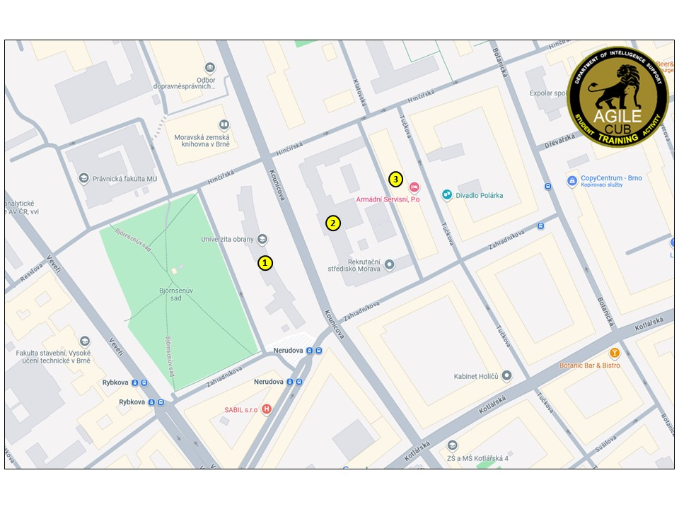

*Map 1 – The University of Defence facilities (Brno) – main building (1), academics during Week 1 (2), dormitory (3)*

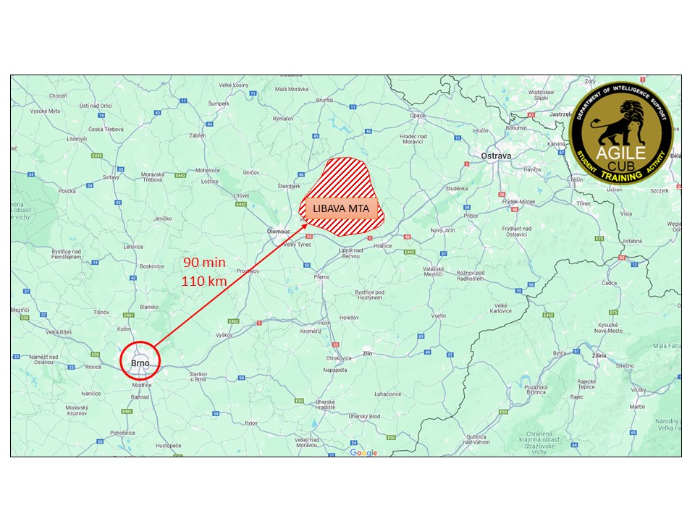

*Map 2 – Distance and travel time from Brno to Libava MTA*