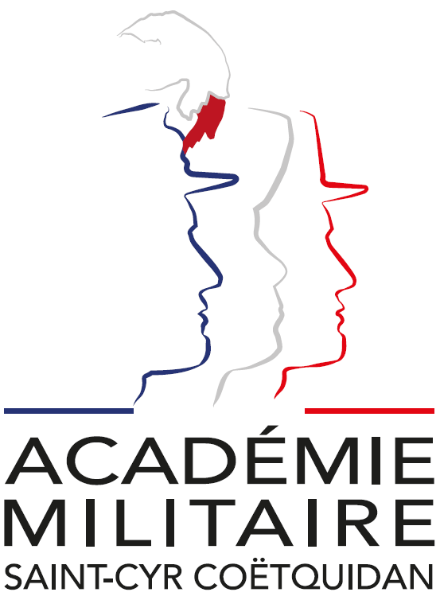

**International Spring Semester**

**2025**

*Smart Robotics (in English)*

|  |  |
| --- | --- |
| Institutional Data Sheet | |
| Erasmus ID code | F GUER01 |
| Erasmus+ Coordinator | First Lieutenant (OF-1) Charlie Offerlin  E-mail: [cyr.international@st-cyr.terre-net.defense.gouv.fr](mailto:cyr.international@st-cyr.terre-net.defense.gouv.fr)  Phone: +33 2 97 70 73 75 |
| Dates | Arrival date: January 21-22, 2025 – *Preferably January 22* - *(Please respect this date)*  Start of the course: January 27, 2025  End of the course: June 12, 2025  Return day: June 13-14, 2025  *Dates may be subject to change* |
| Student Requirements | * B2 level in English * Bachelor of Science |
| Documents required for the application | * Application form * Medical certificate * Reduced medical booklet * ID or Passport scan * 1 ID photo |
| Application deadline | **All applications must be submitted by December 16th, 2024.** |
| Meals & Accommodations | According to EMILYO-LoD 5 (framework), accommodation, meals, and other expenses in relation to the education are free of charge for members of European Union Basic Officer Education Institutions (<http://www.emilyo.eu/node/982>). |
| Additional remarks | All incoming cadets must reach Rennes by their own means. The cadets will be picked up at Rennes airport or train station by a shuttle/bus. Due to limited availability of vehicles, there will be only one pick-up per day; so be aware that you may have to wait a bit if you arrive early. |

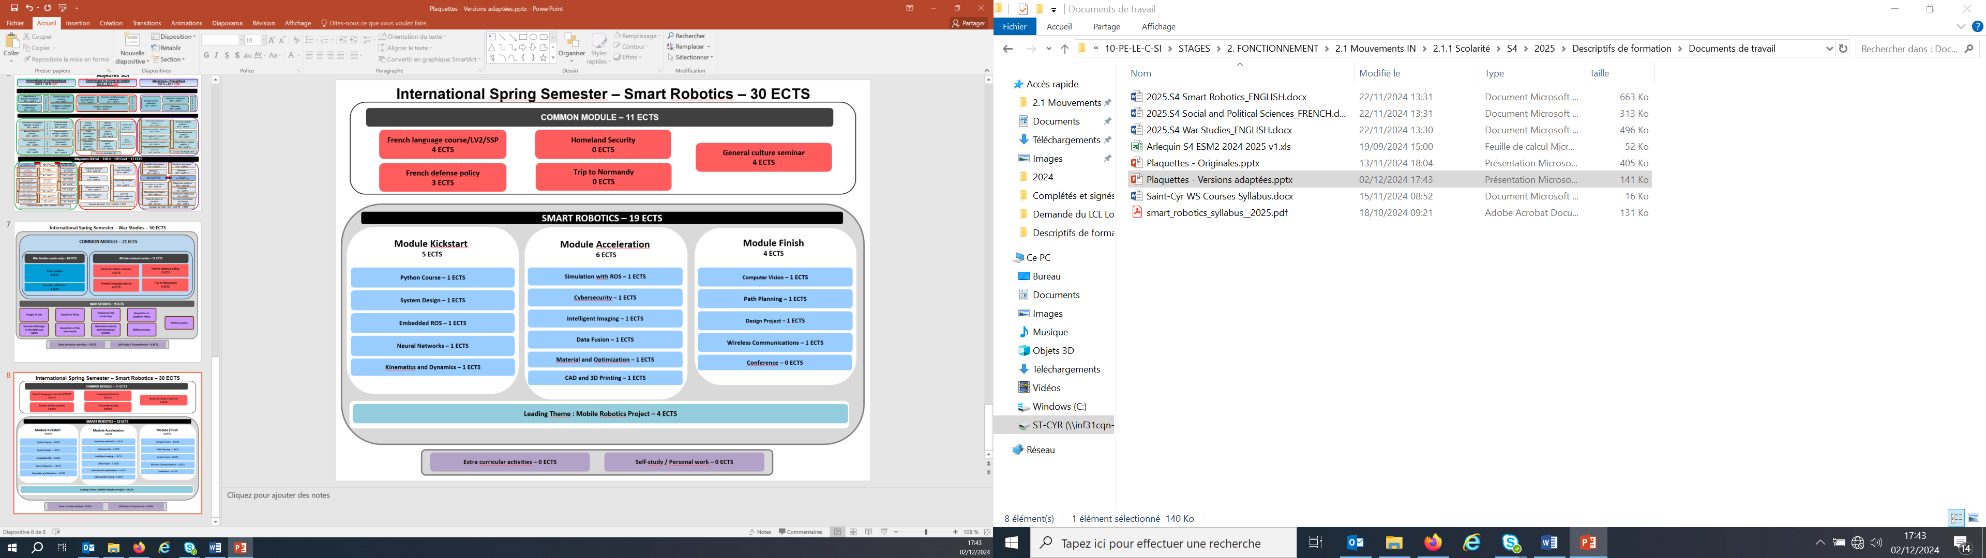

*Smart Robotics: Course Syllabus 2025*

*COMMON MODULE (11 ECTS)*

* *French as second language – 4 ECTS*

This French language course is adapted according to the level of the student. Beginner courses, aim to familiarize with the basics of written and oral French language, through targeted and personalized exercises. Confirmed levels, enable students to strengthen their linguistic skills, through exercises and the study of authentic audio and written documents (films, programs, articles, books). For both levels, the aim of this course is to provide students with notions of civilization and contemporary French culture.

* *General culture seminar – 4 ECTS*

This course, is designed to provide foreign cadets with an understanding of French and French speaking culture, through geography, history, political institutions and cultural notions. Students will also be asked to work on a presentation on a topic of their choosing related to French culture or institutions.

* *French defense policy – 3 ECTS*

The course offers an overview of the French military. The various lectures focus on the current French Defense policy (including the most recent White Paper, and ongoing operations), the organization of the three services and their capabilities. A particular emphasis is laid on the Army (organization, recent engagements, equipment, Special Forces and the Foreign Legion).

* *Homeland security – 0 ECTS*

This course will study Homeland security, policing, peacekeeping, counterterrorism, and counter-insurgency and how crime intersects with formal and informal justice systems in a socio-cultural context. It will also consider information warfare, especially in Americano-Chinese relations. -cultural context.

*LEADING THEME: MOBILE ROBOTICS PROJECT (4 ECTS)*

Smart Robotics is revolving around the Mobile Robotics Project. All the contents provided by the three modules (*Kickstart, Acceleration, and Finish*) will use our mobile robotics platform as a testbed. **Cadets will work in small groups** using the same hardware and software tools. As of today, the mobile robotics platform will be based on a Turtlebot3 Burger robot that is powered by a raspberry pi4 single board computer and an openCR control card. Cadets will be working in small groups, using diverse methods and tools to achieve common goals and challenges.

*SMART ROBOTICS (19 ECTS)*

* *Module 1: Kickstart – 5 ECTS*

This module aims at introducing simultaneously the mobile robotics platform and the fundamental tools to deal with it. Supervised project time is dedicated to make sure the cadets acquire good practice using the robots.

* Python Course – 1 ECTS
  + Language Basics
  + Integrated Development Environment
  + Data types for Robotics, Signal and Image Processing
  + Modules: scipy, numpy, pandas
* System Design – 1 ECTS
  + Requirements expression using SysML
  + Specification
  + Analysis and conception
  + Test and feedback
* Embedded ROS (Robot Operating System) – 1 ECTS
  + Linux/Ubuntu on embedded devices
  + Command Line Tools
  + ROS basics: architecture, tools, communications
  + First robotics experiments
* Neural Networks – 1 ECTS
  + Optimization theory
  + Linear classification and Perceptron
  + NN functions approximation
  + Backpropagation and gradient descent
  + Framework experiment using TensorFlow/Keras
* Kynematics and Dynamics – 1 ECTS
  + Study of the Turtlebot robot
  + Multibody simulations with Matlab
* *Module 2: Acceleration – 6 ECTS*

This module deals with introducing tools to control the robot at a higher level introducing sensors to assess the platform’s environment. Some other basic aspects like energy and security are also taken into account. The cadets will have more supervised project time to gain independence on everyday use of the mobile robotics platform.

* Simulation with ROS 1 - ECTS
  + Use of physics-based simulation in Gazebo
  + Implementation of navigation algorithms
  + RViz as a visualization tool
  + Modelling of robots for simulation
* Cybersecurity – 1 ECTS
  + Operating System deployment on Raspberry Pi
  + Setting Up Network & its Security
  + Cryptography Standards
  + Secured Communications
* Intelligent Imaging – 1 ECTS
  + Image Acquisition
  + Image Compression and Coding
  + Fundamentals of Image Processing
  + Features Extraction
  + Pattern Recognition
* Data Fusion – 1 ECTS
  + Conditional Probability
  + Bayesian Reasoning
  + Belief Distribution
  + Bayesian and Kalman Filtering
* Material and optimization – 1 ECTS
  + Materials for UAV and UGV
  + Sandwich Material for Lightness and Stiffness
  + Shape Optimization
* Computer-Aided Design and 3D Printing – 1 ECTS
  + CAD using SolidWorks
  + Basics of mechanical engineering
  + Structural analysis
  + 3D printing in practice
* *Module 3: Finish – 4 ECTS*

This module is more project-oriented and the cadets use more autonomous working time to achieve challenges connected to mobile robotics. The cadets will bring together more building bricks to perform more complex tasks such as detailed environment assessment and target tracking. They will also present their work during the academy’s science fair alongside the projects of all the cadets.

* Computer Vision – 1 ECTS
  + From 3D to 2D and backwards
  + Multiview geometry
  + Camera calibration
  + SLAM and Visual Odometry
* Path Planning – 1 ECTS
  + Problem Formulation
  + Graph Representation
  + Optimization Methods on Graph
* Design project – 1 ECTS
  + Design and optimization of pieces for mobile robots
* Wireless Communications – 1 ECTS
  + Radio Communications Overview
  + Wireless Protocols
  + Software Defined Radio
* Conferences
  + RADAR

Documents required:

* Application Form (p. 9)
* Medical Certificate (p. 11)
* Reduced Medical Booklet (p. 12 – p.13)

***Application Form***

|  |
| --- |
| Insert Photo Here  (preferably a passport picture in jpg-format or attach the picture to the mail) |
|
|
|
|
|
|
|
|

REMARKS:

* fill in 1 application form for 1 person;
* insert applicant’s photo;
* choose the course (and, if applicable, the module(s)) you would like to attend;
* send the completed form to: [cyr.international@st-cyr.terre-net.defense.gouv.fr](mailto:cyr.international@st-cyr.terre-net.defense.gouv.fr)

|  |  |  |
| --- | --- | --- |
| **Course** | | |
| Social and Political Sciences *(in French)* | War Studies *(in English)* | Smart Robotics *(in English)* |
|  |  |  |

|  |  |  |  |  |
| --- | --- | --- | --- | --- |
| **Male**  (click to mark) | **Female**  (click to mark) | **Rank** | **FAMILY NAME** | **First name(s)** |
|  |  |  |  |  |

|  |  |  |  |
| --- | --- | --- | --- |
| **Date of birth**  (DD/MM/YYYY) | **Nationality** | **Passport or ID number** | **Passport or ID validity until** (DD/MM/YYYY) |
| **Click for date** |  |  | **Click for date** |

|  |  |  |  |  |  |
| --- | --- | --- | --- | --- | --- |
| **Branch of Service** | **Sending institution’s name** | **I want to participate as ….**  (click to mark) | | | |
|  |  | Student | Instructor | Observer | Other |
|  |  |  |  |

|  |  |
| --- | --- |
| **Phone number**  (please include country code) | **E-mail address** |
|  |  |

|  |  |  |  |  |  |
| --- | --- | --- | --- | --- | --- |
| **Arrival** | | | | | |
| **… at Rennes airport**  (click to mark) | **… at Rennes train station**  (click to mark) | **… by (own) car**  (click to mark) | **License plate** (If arrival by car) | **Date** | **Time** |
|  |  |  |  | **Click for date** |  |

|  |  |  |  |  |
| --- | --- | --- | --- | --- |
| **Departure** | | | | |
| **… at Rennes airport**  (click to mark) | **… at Rennes train station**  (click to mark) | **… by (own) car**  (click to mark) | **Date** | **Time** |
|  |  |  | **Click for date** |  |

|  |  |  |
| --- | --- | --- |
| Special dietary or food requirements due to medical or religious reasons  (click to mark) | | **If yes**, please specify food you cannot eat |
| No | Yes |  |
|  |  |

|  |
| --- |
| **Additional remarks**  (need for special equipment, special travel arrangements, etc.) |
|  |

|  |  |  |  |  |
| --- | --- | --- | --- | --- |
| **POC at sending institution** | | | | |
| Male  (click to mark) | Female  (click to mark) | Rank, ac. degree(s) | FAMILY NAME | First name(s) |
|  |  |  |  |  |
| POC’s phone number (include country code) | | | POC’s e-mail address | |
|  | | |  | |

*(The following option concerns only the cadets attending the Social and Political Sciences course)*

|  |  |
| --- | --- |
| **Major** | |
| Sociology and Communication | Geopolitics |
|  |  |

**FRENCH MINISTRY OF DEFENSE**

-------------------------

**MILITARY HEALTH SERVICE**

--------------------------

**MEDICAL CERTIFICATE**

**(n°620-4/1)**

**Last name: First name:**

**Birth date: Rank:**

|  |  |
| --- | --- |
| ***APTITUDES*** | ***Medical decision*** |
| **General** |  |
| **Abroad & overseas** |  |
| **Paratrooper** |  |
| **Commando** |  |

|  |  |
| --- | --- |
| **Job’s restriction details**  **(if needed)** |  |

**CONCLUSION: Date:**

**⁭ Aptitude without restrictions**

**⁭ Aptitude with restrictions Physician’s signature & stamp:**

**⁭ Inability**

**Reduced Medical Booklet**

**Last name: First name:**

**Birth date: Rank:**

**Medical background**

* **Family:**
* **Medical:**
* **Surgical:**
* **Allergy:**

**Treatment:**

**Current medical condition:**

**Work incapacity:**

**Height: Weight:**

**Blood pressure: Pulse:**

**VACCINATION:**

|  |  |  |  |
| --- | --- | --- | --- |
| **TYPE** | **Date of 1st injection** | **2nd injection** | **3rd injection** |
| BCG |  |  |  |
| Diphtheria-Tetanus-Polio-Pertussis |  |  |  |
| Meningitis (A + C) |  |  |  |
| Hepatitis B |  |  |  |
| Measles-Mumps-Rubella |  |  |  |
| INFLUENZAE (H1N1 and seasonal) |  |  |  |
| Meningococcal Tetravalent (A + C + Y + W135 |  |  |  |
| Typhoid |  |  |  |
| Hepatitis A |  |  |  |
| Yellow fever |  |  |  |

**Date: Physician’s stamp and signature:**