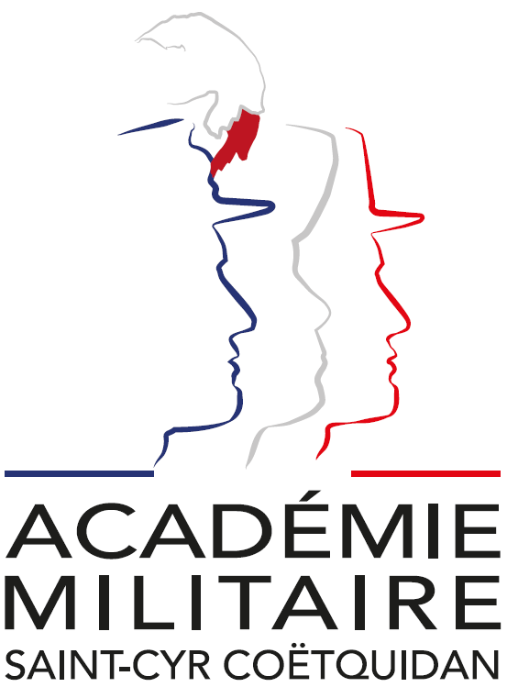

**International Spring Semester**

**2025**

*War Studies (in English)*

|  |  |
| --- | --- |
| Institutional Data Sheet | |
| Erasmus ID code | F GUER01 |
| Erasmus+ Coordinator | First Lieutenant (OF-1) Charlie Offerlin  E-mail: [cyr.international@st-cyr.terre-net.defense.gouv.fr](mailto:cyr.international@st-cyr.terre-net.defense.gouv.fr)  Phone: +33 2 97 70 73 75 |
| Dates | Arrival date: January 21-22, 2025 – *Preferably January 22* - *(Please respect this date)*  Start of the course: January 27, 2025  End of the course: June 12, 2025  Return day: June 13-14, 2025  *Dates may be subject to change* |
| Student Requirements | * B2 level in English * Bachelor of Science |
| Documents required for the application | * Application form * Medical certificate * Reduced medical booklet * ID or Passport scan * 1 ID photo |
| Application deadline | **All applications must be submitted by December 16th, 2024.** |
| Meals & Accommodations | According to EMILYO-LoD 5 (framework), accommodation, meals, and other expenses in relation to the education are free of charge for members of European Union Basic Officer Education Institutions (<http://www.emilyo.eu/node/982>). |
| Remarks | All incoming cadets must reach Rennes by their own means. The cadets will be picked up at Rennes airport or train station by a shuttle/bus. Due to limited availability of vehicles, there will be only one pick-up per day; so be aware that you may have to wait a bit if you arrive early. |

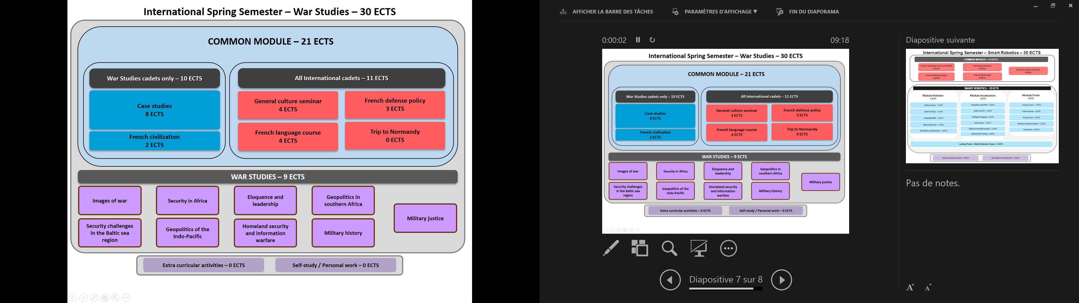

*War Studies: Course Syllabus 2025*

*COMMON MODULE (21 ECTS)*

*War Studies cadets only.*

* *Case studies – 8 ECTS*

During this course cadets will be dispatched in teams to work on a current operation of French forces, analyse the situation and present an operation briefing.

* *French civilization – 2 ECTS*

This course, delivered entirely in French is designed to provide foreign cadets with an understanding of French and French speaking culture, through geography, history, political institutions and cultural notions. Students will also be asked to work on a presentation in French on a topic of their choosing related to French culture or institutions.

*All international cadets.*

* *General culture seminar – 4 ECTS*

This course provides cadets with a better knowledge of France through a mix of lessons and presentations in English on history, geography and culture of France.

* *French defense policy – 3 ECTS*

The course offers an overview of the French military. The various lectures focus on the current French Defense policy (including the most recent White Paper, and ongoing operations), the organization of the three services and their capabilities. A particular emphasis is laid on the Army (organization, recent engagements, equipment, Special Forces and the Foreign Legion).

* *French language course – 4 ECTS*

This French language course is adapted according to the level of the student. Beginner courses, aim to familiarize with the basics of written and oral French language, through targeted and personalized exercises. Confirmed levels, enable students to strengthen their linguistic skills, through exercises and the study of authentic audio and written documents (films, programs, articles, books). For both levels, the aim of this course is to provide students with notions of civilization and contemporary French culture.

*WAR STUDIES (9 ECTS)*

* *Images of War*

The aim of the course is to discover the weight of representations on the conduct of war. What are the relations between the graphic arts and war. How have arts been used to the conduct of war? How have officers used their technical skills to represent military situations?

* *Security challenges in the Baltic Sea Region*

Security in the Baltic Sea Region is very often mentioned as a major issue with the enlargement of NATO. The aim of the course is to have a study in depth of the security challenges and policies in the Baltic Sea region. Some of the key issues will be political and military cooperation, military exercises, geopolitical tensions, economic integration, strategic economic activities (fishing, mining and shipping) and climate change.

* *Security in Africa*

The course is about the many security aspects of the African continent. It focuses on military issues in different areas like Western Africa or the Horn of Africa. It also insists on current dynamics: radicalization, terrorism, jihadism, political instability, border conflicts, resources management, food security or climate change. It will encompass the logics of players in international relations: local and federal authorities, foreign powers (the US, the UK, France, Russia or China), the international community (UNO, UNHCR, UNICEF), NGOs or TNCs.

* *Geopolitics of the Indo-Pacific*

The aim of the course is to have a study in depth of both concept and reality by focusing on main actors: states such as the US, China, India, Japan, Australia, France and the EU; regional organizations; TransNational Companies; NGOs and transnational organised crime. The key issues will be regional order, strategy and vision, diplomacy, policies, cooperation and integration, military tensions, piracy, terrorism, energy resources, natural resources, major shipping routes, submarine cables, migration patterns and remittances. The methodology is based on many case-studies of subregions and strategic chokepoints: the Malacca Strait, the Taiwan Strait, the South China Sea, the East China Sea, the Indian Ocean, the horn of Africa and the Strait of Bab-el-Mandeb, the Strait of Hormuz, the Indian subcontinent, Australia, New-Zealand and the Pacific islands. Teamwork, cooperative spirit and team communication skills will be required.

* *Eloquence and Leadership*

Cadets will work eloquence with an English language trainer, a public speaking specialist and image consultant: communication, personal image, charisma, and team building.

* *Homeland security and information warfare*

The aim of this course is to study homeland security in the US since 2001 and to address new challenges in terms of security and war: use and management of information and communication technology, cyber, medias, fake news, influences, propaganda, disinformation, etc.

* *Geopolitics in Southern Africa*

This course will examine Geopolitics in Southern Africa, stressing examples of South Africa, Namibia, Mozambique and Angola. International relations, Military issues, Security issues and Piracy, among others, will be at the heart of this class.

* *Military History*

This course will be dedicated to the History of Napoleonic wars in Europe.

* *Military Justice*

Through comparison between legal systems, this course will study the broad principles of military justice (procedure, offences and punishments, human rights of members of armed forces, etc.). Contemporary issues will also be addressed, such as the evolution and functioning of military justice in wartime (Israel, Ukraine).

Documents required:

* Application Form (p. 8)
* Medical Certificate (p. 10)
* Reduced Medical Booklet (p. 11 – p.12)

***Application Form***

|  |
| --- |
| Insert Photo Here  (preferably a passport picture in jpg-format or attach the picture to the mail) |
|
|
|
|
|
|
|
|

REMARKS:

* fill in 1 application form for 1 person;
* insert applicant’s photo;
* choose the course (and, if applicable, the module(s)) you would like to attend;
* send the completed form to: [cyr.international@st-cyr.terre-net.defense.gouv.fr](mailto:cyr.international@st-cyr.terre-net.defense.gouv.fr)

|  |  |  |
| --- | --- | --- |
| **Course** | | |
| Social and Political Sciences *(in French)* | War Studies *(in English)* | Smart Robotics *(in English)* |
|  |  |  |

|  |  |  |  |  |
| --- | --- | --- | --- | --- |
| **Male**  (click to mark) | **Female**  (click to mark) | **Rank** | **FAMILY NAME** | **First name(s)** |
|  |  |  |  |  |

|  |  |  |  |
| --- | --- | --- | --- |
| **Date of birth**  (DD/MM/YYYY) | **Nationality** | **Passport or ID number** | **Passport or ID validity until** (DD/MM/YYYY) |
| **Click for date** |  |  | **Click for date** |

|  |  |  |  |  |  |
| --- | --- | --- | --- | --- | --- |
| **Branch of Service** | **Sending institution’s name** | **I want to participate as ….**  (click to mark) | | | |
|  |  | Student | Instructor | Observer | Other |
|  |  |  |  |

|  |  |
| --- | --- |
| **Phone number**  (please include country code) | **E-mail address** |
|  |  |

|  |  |  |  |  |  |
| --- | --- | --- | --- | --- | --- |
| **Arrival** | | | | | |
| **… at Rennes airport**  (click to mark) | **… at Rennes train station**  (click to mark) | **… by (own) car**  (click to mark) | **License plate** (If arrival by car) | **Date** | **Time** |
|  |  |  |  | **Click for date** |  |

|  |  |  |  |  |
| --- | --- | --- | --- | --- |
| **Departure** | | | | |
| **… at Rennes airport**  (click to mark) | **… at Rennes train station**  (click to mark) | **… by (own) car**  (click to mark) | **Date** | **Time** |
|  |  |  | **Click for date** |  |

|  |  |  |
| --- | --- | --- |
| Special dietary or food requirements due to medical or religious reasons  (click to mark) | | **If yes**, please specify food you cannot eat |
| No | Yes |  |
|  |  |

|  |
| --- |
| **Additional remarks**  (need for special equipment, special travel arrangements, etc.) |
|  |

|  |  |  |  |  |
| --- | --- | --- | --- | --- |
| **POC at sending institution** | | | | |
| Male  (click to mark) | Female  (click to mark) | Rank, ac. degree(s) | FAMILY NAME | First name(s) |
|  |  |  |  |  |
| POC’s phone number (include country code) | | | POC’s e-mail address | |
|  | | |  | |

*(The following option concerns only the cadets attending the Social and Political Sciences course)*

|  |  |
| --- | --- |
| **Major** | |
| Sociology and Communication | Geopolitics |
|  |  |

**FRENCH MINISTRY OF DEFENSE**

-------------------------

**MILITARY HEALTH SERVICE**

--------------------------

**MEDICAL CERTIFICATE**

**(n°620-4/1)**

**Last name: First name:**

**Birth date: Rank:**

|  |  |
| --- | --- |
| ***APTITUDES*** | ***Medical decision*** |
| **General** |  |
| **Abroad & overseas** |  |
| **Paratrooper** |  |
| **Commando** |  |

|  |  |
| --- | --- |
| **Job’s restriction details**  **(if needed)** |  |

**CONCLUSION: Date:**

**⁭ Aptitude without restrictions**

**⁭ Aptitude with restrictions Physician’s signature & stamp:**

**⁭ Inability**

**Reduced Medical Booklet**

**Last name: First name:**

**Birth date: Rank:**

**Medical background**

* **Family:**
* **Medical:**
* **Surgical:**
* **Allergy:**

**Treatment:**

**Current medical condition:**

**Work incapacity:**

**Height: Weight:**

**Blood pressure: Pulse:**

**VACCINATION:**

|  |  |  |  |
| --- | --- | --- | --- |
| **TYPE** | **Date of 1st injection** | **2nd injection** | **3rd injection** |
| BCG |  |  |  |
| Diphtheria-Tetanus-Polio-Pertussis |  |  |  |
| Meningitis (A + C) |  |  |  |
| Hepatitis B |  |  |  |
| Measles-Mumps-Rubella |  |  |  |
| INFLUENZAE (H1N1 and seasonal) |  |  |  |
| Meningococcal Tetravalent (A + C + Y + W135 |  |  |  |
| Typhoid |  |  |  |
| Hepatitis A |  |  |  |
| Yellow fever |  |  |  |

**Date: Physician’s stamp and signature:**