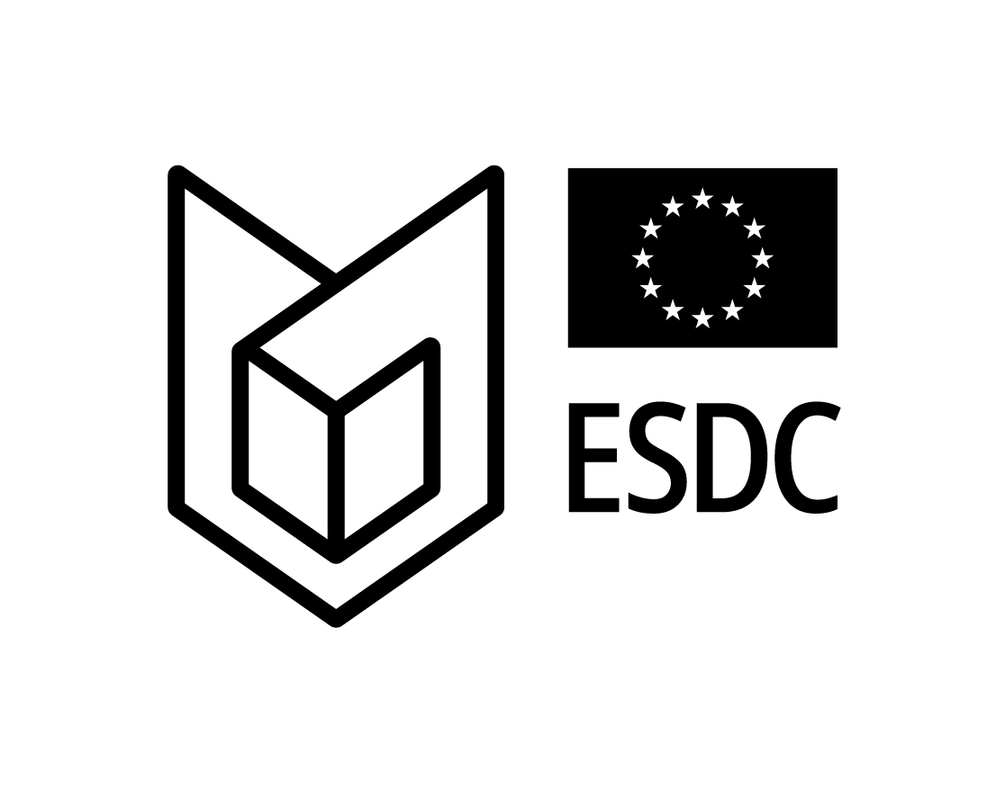 | 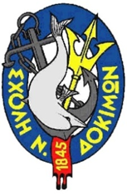 | 

HELLENIC NAVAL ACADEMY
MARITIME SECURITY COMMON MODULE
hosted in Piraeus (GREECE) from March 31st to April 4th 2025

Administrative Information

- General
Fifty (50) participants will be admitted including:
- Hellenic Naval and Coast Guard Cadets / Young Military Officers.
- Hellenic Army and Air Force Cadets / Young Military Officers.
- Civilian University (Domestic) Students in Strategic Science.
- Up to thirty (30) Foreign Cadets / Young Officers.

The module will be held in English language; thus, an adequate knowledge of the language is necessary (equivalent to Common European Framework of Reference for Languages (CEFR) Level B2). A basic knowledge on the structure and history of the European Union is prerequisite. No course fees will be required.

- Course fee-Accommodation-Meals
Course fee: No Course fee is required.

Accommodation:
- For the participating foreign cadets / young officers, accommodation will be provided in the Academy's campus, free of charge.
- For the escorts and civilians, reservation at own arrangements in any hotel downtown Piraeus is recommended.

Meals: Three (3) meals per day will be provided by the Hellenic Naval Academy (HNA) in the Academy's campus, free of charge.

- Transportation
- Transportation from Athens International Airport (AIA) will be provided by the HNA on March 30th 2025 from 08:00 to 20:00.
- You will be received at the arrival terminal of the airport by a HNA representative bearing a “MSCM 2024@HNA” logo.
- Transportation to Athens airport will be provided by the HNA not earlier than 15:30 on April 5th 2025.
- Public train, buses and taxis are also available from / to AIA to / from Piraeus at convenient prices.

- Hellenic Naval Academy Location
The Hellenic Naval Academy is located at the end of Hatzikyriakou Street No.48, Piraeus (Postal Code:185 38), Greece.

- Registration
- Applicants are kindly requested to submit to POC the attached application form filled in, not later than March 9th 2025 (flight info may be sent when available after registration).
- Registration is open on a “first come-first served” basis.
- Please be aware that according to regulations, participation to the residential session is feasible only after successful accomplishment of the e-Learning part.
- Access to the server for IDL (e-learning phase) will be provided personally to applicants after successful registration via mail by POC.
- Access to the server for IDL (e-learning phase) will be closed on March 9th 2025 (23:59 UTC)).
- Flight data will be required after the validation of the registration.

- Dress Code
- Upon arrival / departure and sightseeing: Casual.
- During opening / closing Ceremony: Official uniform (Class “A”) and equivalent for civilians (jacket & tie).
- Educational session: Service uniform (Class “B”) and equivalent for civilians (Smart casual).
- Ice breaking event and dinners: Smart casual.

- POC
Lt Panagiota Efthimiou GRC-A
- Phone: +302104581627, +306982852759
- E-mail address: cel.efthimiou@hna.gr

