 |  | “SEAMANSHIP TRAINING MODULE”  Romanian Naval Academy -CONSTANTA/ROMANIA  23th – 27th of June 2025  Application form | 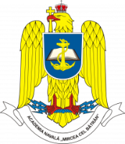

Sending institution | Country of origin | Institutional address

Rank | Service | M/F | Family name | First name | Passport number | Date of birth

Nationality | Mobile phone number | e-mail address | Dietary restriction, if any

Arrival at  Bucharest/Otopeni Airport | Need transfer? | Arrival date/ETA | Flight no.
Departure from  Bucharest/Otopeni Airport | Need transfer? | Arrival date/ETD | Flight no.

Additional remarks (need for special equipment, special travel arrangements, ….)

Point of contact (POC) of sending institute
Rank | Family name | First name | e-mail address | phone number

Remarks:
- Please fill in the yellow fields only. One form to be filled in for all participants/per institution.
- The flight details will be extended once available.

Upon completion submit the final form to RNA PoC: Cdr Marius Cucu, international@anmb.ro

